更新日期：2018-09-08

（单位：mm）

样本

M12-3FVL-02AYP, M12-3FVL-02AYN
M12-3FVL-02BYN, M12-3FVL-02BYN
M12-4FVL-02CYN, M12-4FVL-02CYP
M12-5FVL-02CYN, M12-5FVL-02CYP
M12-8FVL-02Y
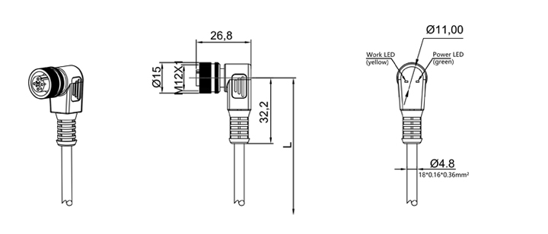

M12-3FVR-02AYP, M12-3FVR-02AYN
M12-3FVR-02BYN, M12-3FVR-02BYN
M12-4FVR-02CYN, M12-4FVR-02CYP
M12-5FVR-02CYN, M12-5FVR-02CYP
M12-8FVR-02Y
