更新日期：2018-09-08
（单位：mm）

本体

M12-3FVR-02, M12-4FVR-02
M12-5FVR-02, M12-8FVR-02
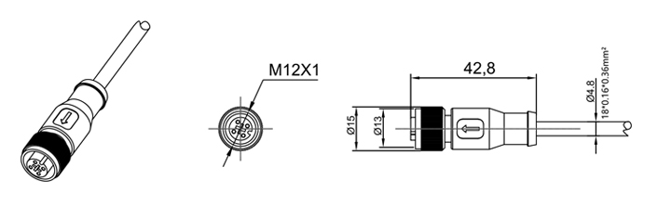

M12-3FVR-02AYN, M12-3FVR-02AYP
M12-4FVR-02CYN, M12-4FVR-02CYP
M12-5FVR-02CY, M12-8FVR-02Y
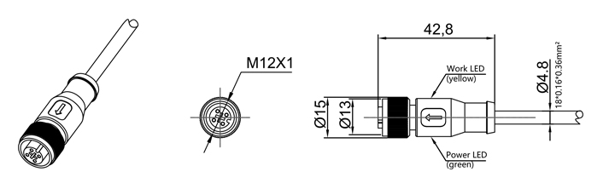

M12-3MVL-02, M12-4MVL-02
M12-5MVL-02, M12-8MVL-02
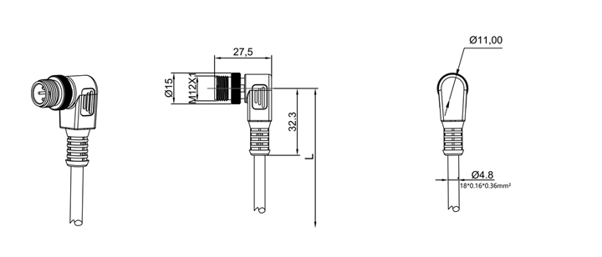

M12-MFVL-02AYN, M12-3MVL-02AYP
M12-4MVL-02CYN, M12-4MVL-02CYP
M12-5MVL-02CY, M12-8MVL-02Y
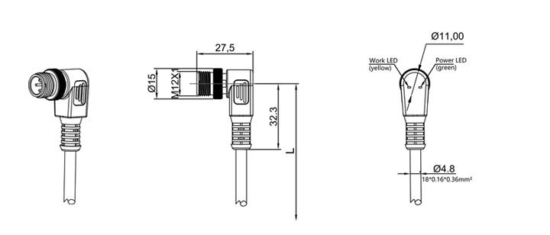

M12-3FVR-02, M12-4FVR-02
M12-5FVR-02, M12-8FVR-02
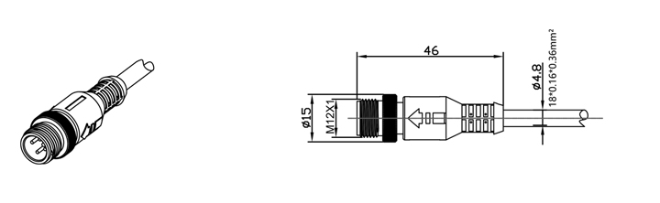

M12-3MVR-02AYN, M12-3MVR-02AYP
M12-4MVR-02CYN, M12-4MVR-02CYP
M12-5MVR-02CY, M12-8MVR-02Y

