单位：mm）

本体
FN08-10BNA,FN08-10BNB

FN08-10BPA,FN08-10BPB
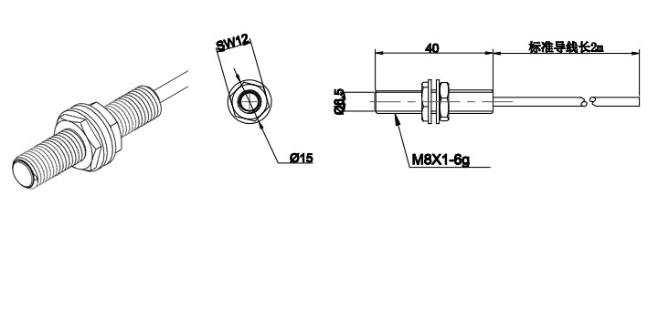

FN12-10BNA,FN12-10BNB
FN12-10BPA,FN12-10BPB

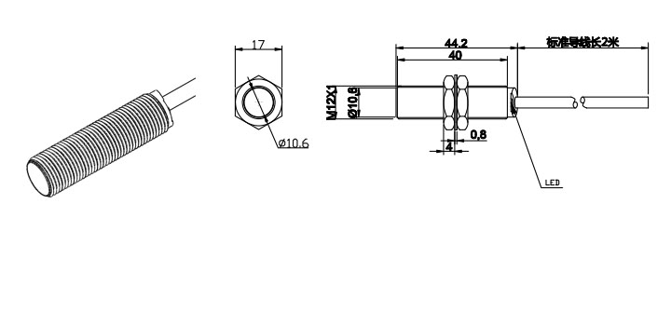

FN18-10BNA,FN18-10BNB
FN18-10BPA,FN18-10BPB

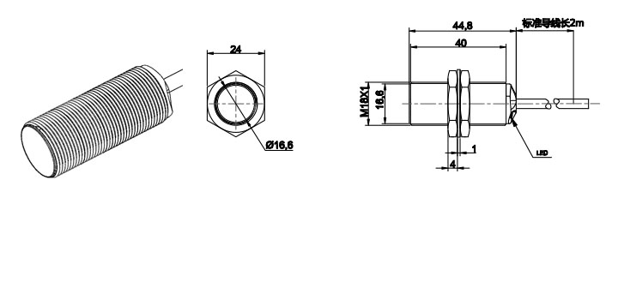

FP08-10BNA,FP08-10BNB
FP08-10BPA,FP08-10BPB

